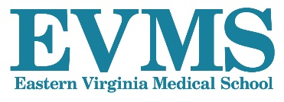
URM Scholarship for EM Clerkship

The Department of Emergency Medicine at Eastern Virginia Medical School (EVMS) is excited to offer a scholarship for a visiting underrepresented minority student. The department will provide a stipend up to $1500 against receipts related to registration, travel, lodging, meals, and other necessary expenses associated with completing our four-week Emergency Medicine elective rotation.

This scholarship is for rising 4th year medical students who are committed to pursuing a career in emergency medicine and completing an EM elective rotation at EVMS.

Eligibility requirements:

1) Will be a senior medical student in good standing at an accredited U.S. medical school

2) Meet EVMS requirements for acceptance into the EVMS EM Clerkship

3) Member of a traditionally underrepresented racial/ethnic minority group (e.g., American Indian/Alaska Native, Black/African American, Hispanic/Latino, or Native Hawaiian/Other Pacific Islander)

4) Letter of recommendation from a faculty member who can attest to the applicant’s interest in EM.

How to apply: Applicants must apply for the elective through VSLO. Applicants will need to fill our a short application to be considered. For further EVMS EM Clerkship details, please visit our website:

https://www.evms.edu/emergency_medicine/fourth-year_medical_student_elective/

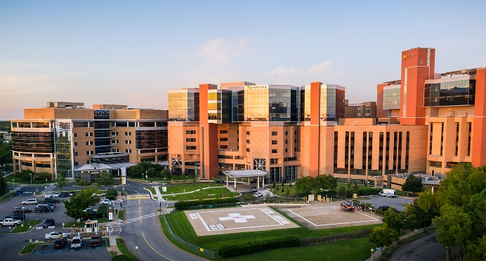
Emergency Medicine
600 Gresham Drive
Raleigh Building, Room 304
Phone: (757) 388-3397
Fax: (757) 388-2885

